

Dr. Ryan, Liu inc.

2019-08-06

Dr. Liu

0212 Brown Street, East Melvin, HI 53454

Phone: 3446867921

Fax: 5768141094

**Re:** Pamela, Nguyen

**PHN:** 1086732820

**Birthdate:** 10-Jan-1998

**Address:** 923 Jennifer Flat, Martinezfurt, WV 85720

**Patient number:** 2784749448

To Whom It May Concern:

This is a medical letter to state the above patient is pregnant with expected delivery date of 27-Feb-2025. Hoping this information is satisfactory for your requirements.

Thank you.

Sincerely,

Dr. Ryan, Liu

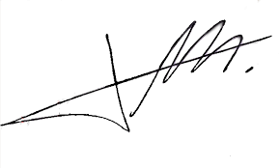

FRCS© NCMP

Clinical Assistant Professor, UBC

Department of Obstetrics and Gynecology SMH